Linux partition

Due date: at the end of your lab period

Note: all commands in this lab will be used during quizzes and exams.

Mark: 20

7 screenshots

13 questions

Marking scheme: Missing any snapshot or wrong answer for each question would costs 1 mark

Purpose:

* Create a Linux **clone**
* create and remove **MBR partitions** from a Linux Virtual Hard Disk (2 GB)
* change **Sudo password** (administrator password)
* install the **tree** application

Procedure:

Important: - in this lab, we will be using the Linux **clone** in case you mess things up. there are some questions in the lab, make sure you answer the questions in RED and have snapshots of your work.

All commands in this lab are lower case.

**Create a clone of your Linux os**

Please turn on and log in to your Ubuntu. You are learning how to **shut down** Linux through the command line (**Terminal).**

How to **shutdown** your Ubuntu in the command line or **terminal:**

On your Ubuntu desktop press **Ctrl+alt+T** at the same time. On the user prompt type: **sudo shutdown -h now**  press **enter**  (all lower case) (exam)

Provide the **user password**



now your VM is off and you are on the VM main page.

3-In your VM screen select **VM** => Manage => **Clone**

To create **clone** partition.

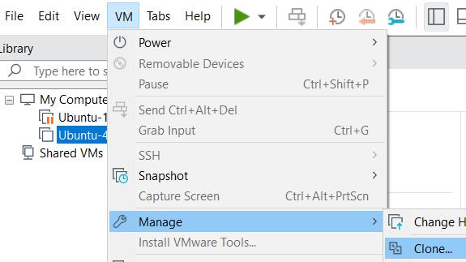

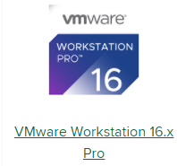

Click **Next**

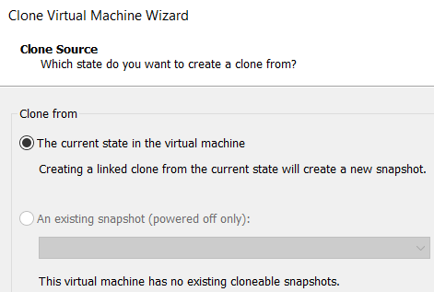

Click **Next**

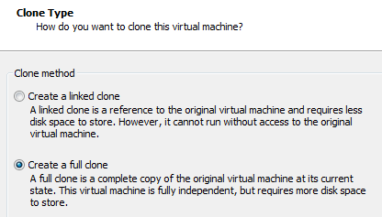

After going through the default setting the **clone type** screen

comes up, select **Create a full clone** click **Next**

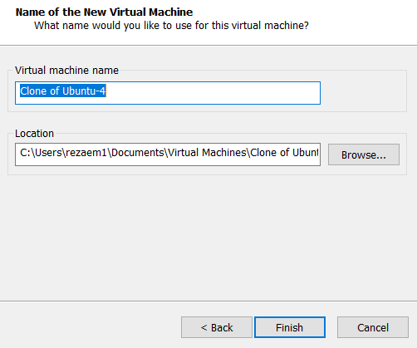

Click **Next**

Then **finish**

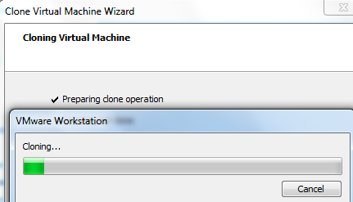

The cloning process takes a few minutes

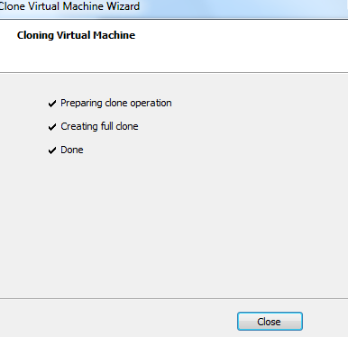

Click **Close**

Adding a new virtual hard drive (2 GB) to the **clone** VM

Select your Linux **clone** from your VM library and add a new virtual hard disk. Double click on your VM **hard Disk (SCSI),** this brings up the **Virtual Machine** **Settings** as shown in Figure 1 below. Note: your hard drive type may not be SCSI, which is **ok.**

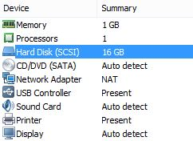

Figure 1 Double Click on the Hard Disk (SCSI)

Select the **Hard Disk** and click on the **Add** button; located at the bottom of the screen on the left-hand side.



This brings up the **Add Hardware** **Wizard**, see Figure 2. Select the **Hard Disk** and click the **Next** button.

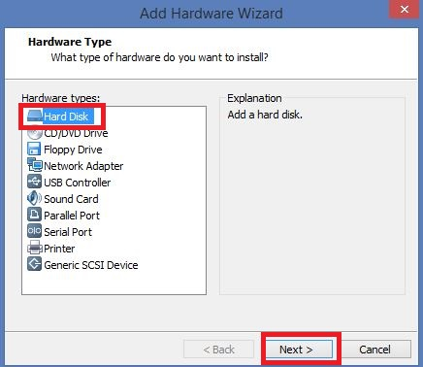

Figure 2 Add Hardware Wizard.

Accept the default options from the **Select a** **Disk Type** Menu and click the **Next** button. Select the **Create a new virtual disk** radio button and click the **Next** button.

Select a **Maxim disk size of** **2 GB** and choose the **Store virtual disk as a single file**, as shown in Figure 3 below.

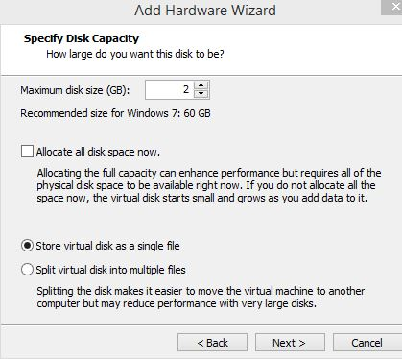

Figure 3 Hard Disk Size.

Click the **Next** button and accept the default name for the disk file. Click **Finish.**

You will now be taken to the **Virtual Machine Settings** menu, and you should see a **2 GB** drive displayed. Click the **OK** button.



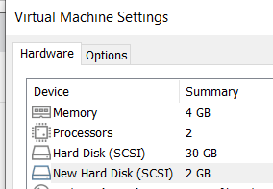

**Screenshot 1**: showing 2 GB drive (1 Mark)

Power on the **Virtual Machine (Clone Ubuntu)** and log on to your Linux VM.

***Exercise 1: Viewing existing partitions from Terminal***

On the Ubuntu desktop screen, press the **Ctrl + alt +T** buttons at the same time. That takes to the **terminal** screen.

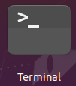

Switch to the **root user** (administrator) with the command: **sudo -s – root** press **enter**

When prompted enter your **root** password (user password) and hit **enter**, remember nothing will show on the screen when you type your **password.** (**Exam**). Linux is a case-sensitive operating system.

**Note**: the prompt user has been changed from **~$** to **~#** (sudo prompt) (Exam)

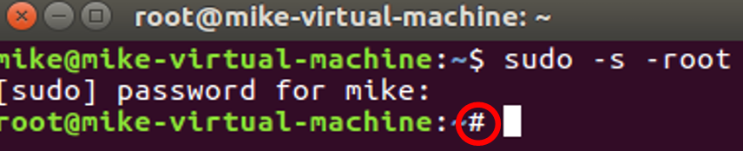

Viewing an existing partition in the drive /Dev/sda (memorize these letters)

To create or see partitions in Linux, we will be using **fdisk** command **(Exam)**

The syntax of the **fdisk** command is ~# **fdisk */dev/device_name (example)***

Type **fdisk /dev/sda**  press **enter (be careful, there is a space between fdisk and /dev/sda)**

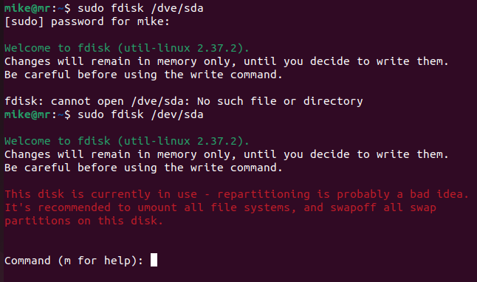

Within the **fdisk** utility type **m** for a list of menu options at the "Command (**m** for help):" prompt

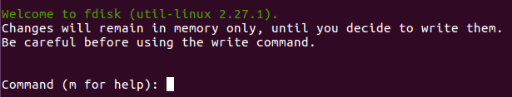

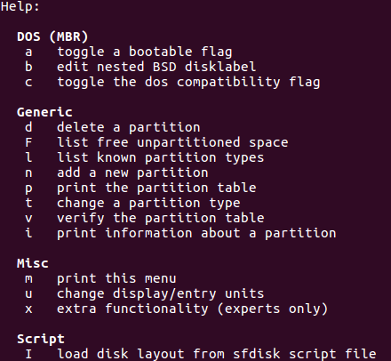

**List of letters or commands to memorize (exam)**

**Questions**

* Record the (one-character) **fdisk** command to:( in Red) (6 mark)
  + Display/print all partitions: ____
  + create (add ) a new partition:  ___
  + delete a partition: ____
  + change partition types: ____
  + save changes made to the partition table: ___
  + exit **fdisk** without saving: ___
* Select the option that lists the **partition types** and record the **system id** of the following
* **Note:** System ID numbers are on the **left** side of the column. example: 85 Linux extended

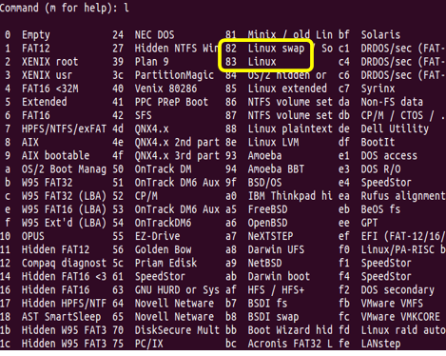

* + "Linux ": _____
  + "Linux swap": _____

In the terminal **command (m for help) type p to display all partitions in the /dev/sda**

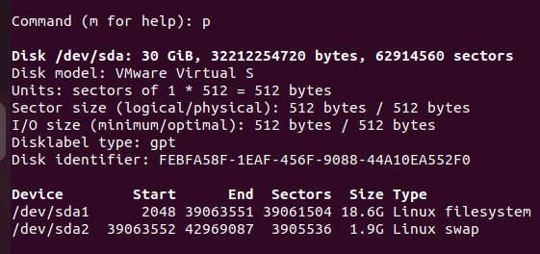

Questions: (2 marks)

How many Devices (partitions) do you see in the /dev/**sda** partition?

What is device name 1: What is the size of device 1 in GB?

What is device name 2: What is the size of device 2 in GB

**Screenshot 2**: two partitions (/dev/**sda)** your name (1 mark)

At the prompt type**quit** and then **exit** to get out from your **root** user account. Now you are in your **user** prompt (you are not a **sudo** administrator anymore)

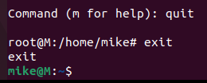

Close the **Terminal** by clicking on the **X** on the top of the screen

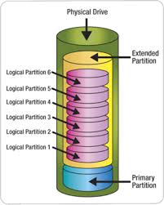

**partition color legend**

*primary=Blue*

*Extended=Yellow*

*Logical=Pink*

***Exercise 2: creating and partitioning 2GB Hard drive (/Dev/sdb***

In this exercise, you will create **2 primary, 1 extended, and 3 logical** partitions inthe **/Dev/sdb**

Start the **Terminal** and switch to **root** user with the command: **sudo -s – root**

When prompted enter your **root** password and hit **enter**, remember nothing **will show** on the screen when you type your password. (**Exam**)

**Create Primary partition:**

1-Switch to the new **hard drive**  by typing: **fdisk /dev/sdb**

2-Press **m** to see the list of the letters (commands). Now choose **P** to see the number of partitions in the /dev/**sdb.**

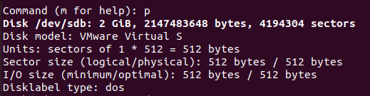

You should see a **2 GB** partition.

3-At the prompt Command (m for help): **n**  (to create a partition)

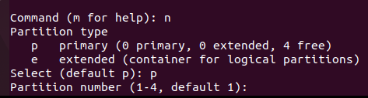

4-Now on the Command prompt choose **p** (to choose a primary partition) and select the number **1** for the partition number. Accept the default for the **first sector** by pressing the **Enter** key. The size of the first primary partition is 500MB**,** so type **+500M** and press **ente**r

Note: make sure you follow the below figure exactly

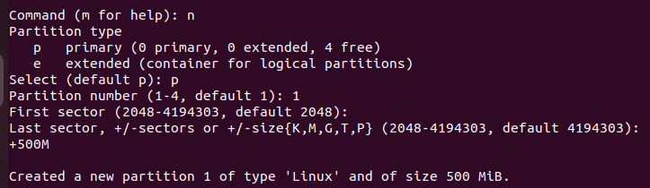

Press enter

Press enter

Now press the **p** key to display the first primary partition (500 MB) you just created in the partition table.



Now you will create the **second primary** partition in /dev/sdb

Create another primary partition by selecting the **n** key, then select **p** for the primary partition and select the number **2** for the partition number. Accept the default for the first sector by pressing the **Enter** key. The size of the second primary partition is **200MB,** soenter **+200M** and press the **enter** key.

**Create Extended partitions:**

Create an **extended** partition to host **three logical** drives - keep in mind that you must make it large enough to encapsulate the logical drive described below. HINT: There will be problems if you try to make it exactly **1000MB.** So you will need to experiment; try entering **1005MB** instead:

5-To create an **extended** partition press the **n** key, then select the **e** key for an **extended** partition. Select the number **3** for the partition number. Accept the default for the first sector by pressing the **Enter** key. Type +**1005M** and press the **enter** key.

Press the **p** key to **display** the **two primary** and **one extended** partitions you just created in the partition table.

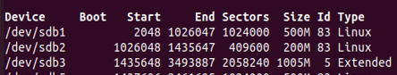

**Create Logical partitions:**

6-To create a **logical** partition inside of the **extended** partition press the **n** key and then select the **L** key for a logical drive. The size of the **first** logical partition should be **500 MB**. Accept the default for the first sector by pressing the **Enter** key.so enter **+500M** and press the **enter key.**

Press the **p** key to display the **2 primary**, **1** **extended**, and **1** **logical** drive (500 MB) you just created.

7-To create a second **logical** drive in the **extended** partition press the **n** key and then select the **L** key for a logical drive. Accept the default for the first sector by pressing the **Enter** key. The size of the second logical drive should be **300MB**, so enter **+300M** and press the **enter** key.

Press the **p** key to display the **2 primary**, 1 **extended**, and 2 **logical** partitions you just created.

8-To create a third **logical** drive in the **extended** partition press the **n** key and then select the **L** key for a logical drive. Accept the default for the first sector by pressing the **Enter** key. The size of the third logical drive should be **200MB** so enter **+200M** and press the **enter** key**.**

**Note: You may get an error: value out of range depending on the size you made your**

**extended partition. If you get an error, delete all logical and extended partitions only and recreate a bigger extended partition (1005M). If you did not get any error, then continue.**

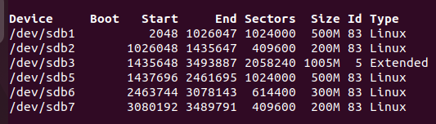

Example of partitions

Now press the **p** key to display all **2 primary**, **1 extended**, and **3 logical** partitions you just created. Record the output by taking a **screenshot** using the Windows **Snipping tool** (snapshot) and put it here:

**Screenshot 3:** showing all partitions (your name) (1 mark)

## ***Exercise 3: Changing Partition Types***

1. You will notice all the partitions are of type **Linux (83).** We want to change the **/dev/sdb7 Linux** (the last logical)partition to a **Linux Swap** (**82)** partition. To change the partition to **Linux Swap** Partition press the **t (change a partition type)** key then enter **7** to select the **7th partition**. When prompted for the **Hex** code, enter **82** and hit the enter key. **82** is the hex code for a **Linux Swap partition**. If you want to see, the other codes available to you enter the **l** key when prompted for the hex code.

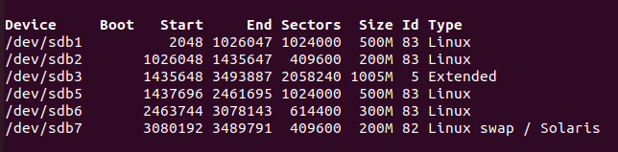

1. Press the **p** key to display the 2 primary, 1 extended 3 logical drives you just created. Record the output by taking a **screenshot** using the Windows Snipping tool and pasting it here:

**Screenshot 4:**changing partition7: (your name**)** (1 mark)

**5 Questions to test your understanding (in Red)** ( 5 mark)

|  |  |
| --- | --- |
| List all the **primary** partitions on the 2GB drive |  |
| List the **extended** partition on the 2GB drive |  |
| List all **logical** drives on the 2GB drive |  |
| Can you create additional **primary** partitions on the 2 Gb drive? | Yes, or No, and Why? |
| Can you create an additional **logical** 100 MB on the 2 Gb drive? | Yes or No and why? |

## 

## ***Exercise 4: Deleting a Partition (logical)***

1-We will be deleting the **300MB logical (/dev/sdb6)** partition.

To delete a partition, press the **d** key, you will be prompted for the partition **number** that you want to delete, press the **6** key, and hit the **enter** key as that is the partition that we wish to delete.

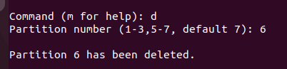

2-Press the **p** key to display the partition table. **Record** the output by taking a screenshot using the WindowsSnipping tool and pasting it here:

**Snapshot 5:** Deleting partition 6 (your name) (1 mark)

3-What do you notice in terms of partition numbering?

**4-Save y**our work to the **hard disk** by pressing the **w** key, this writes the partition table information to the hard disk

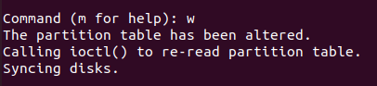

**Note: you may get a red warning failed to add partition 5 or 6 system: Device or resources busy. regarding the kernel is busy.**  Ignore it.

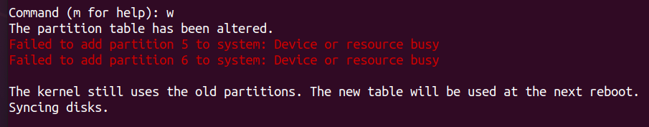

5-Press the **q** key to quit fdisk program

6-Type **exit** to get out of the **user root** (administrator)

**7-Reboot** your Ubuntu.

8-Go back to the **Terminal,** change to the **sudo** user again, and use **fdisk /dev/sdb**

9-Choose **p** to see all partitions that you have created are saved

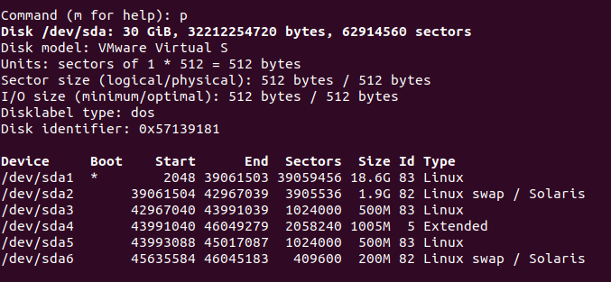

***Exercise 5: Changing sudo (root) password in Ubuntu***

By default in Ubuntu, the **root password** does **not exist** or set, therefore you must set the **root password.**

**Note: root** user password is different from the **user** password. You should **Save** the **root** password somewhere safe.

To set the **root user password**, in the terminal type: **Sudo passwd root** press **Enter** if prompts you for your **Linux password**, this is the same password that you login to your Linux virtual machine (**user password**)

mike@m:~$ **sudo passwd root** [sudo] password for mike: pass (my user password to Linux) **New password**: mike (**root user password**) **Retype new password**: mike **passwd**: password updated successfully

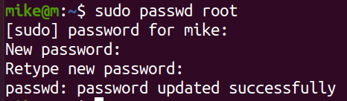

**screenshot 6:** sudo password renewed (your name) (1 mark)

To verify the **root password**: at the prompt type: **su - root** press **Enter** you will notice the prompt changes to **#** (sudo prompt) instead of **$** (user prompt)

To get out of **sudo user** prompt and go back to the user prompt, at the prompt type **exit**

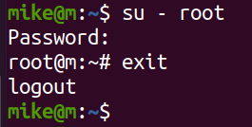

***Exercise 6: Installing Tree application in Linux***

In the Linux environment, to install an application you must be a **sudo** user. Open the **terminal,** at the user prompt type: **sudo apt get install tree,** and press **Enter** to provide the **user password**. Ubuntu begins to install the application



Installing tree application:

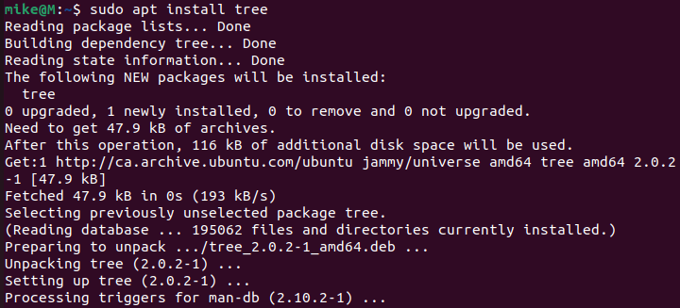

To verify the **tree** application has been installed, at the prompt type: **tree** press **Enter**

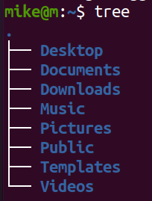

Screenshot 7: tree command (your name) (1 mark)

|  |  |
| --- | --- |
| Answer questions | 13 |
| screenshot | 7 |
| Total | 20 |